Summer Reading 2022: Oceans of Possibilities
with Storyteller, Jen Strauss
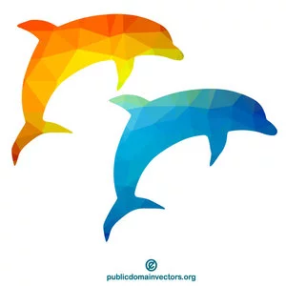
Swimming with Dolphins & Swaying with Whales: Science, Stories and Songs from the Deep Blue Sea
Join Storyteller and Science Teacher, Jenifer Strauss for a multi-media program featuring ocean facts, folklore and silly songs about the sea. Jen will be combining story, science and songs featuring well-loved Dolphins and Whales and other Salt Water Faves! Make a Pirate Hat and leave the program talking like a pirate.

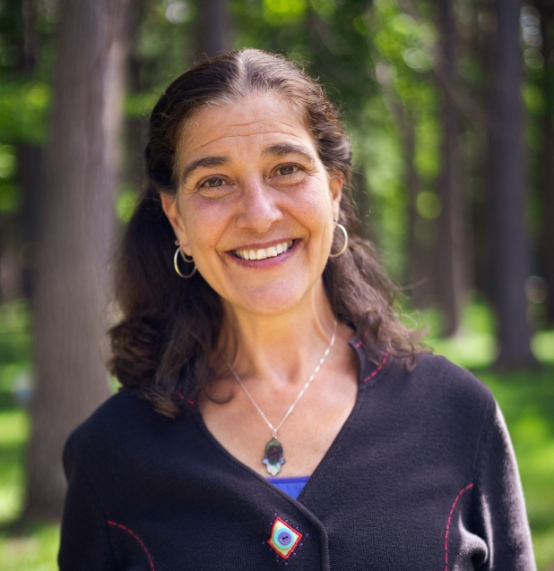
About Storyteller, Jen Strauss:
For 30 years, Jen has created library programs for children, adults and teens using the National Summer Reading theme. A former teacher, Jen discovered the power of story to motivate and inspire her students. In 1993, she created her business, Story Be Told and has been enriching over 300 audiences a year with her own unique brand of energy-injected performances, workshops, trainings
and keynotes.

